**DATA ANALYSIS PROJECT**

**The Tableau HR Scorecard**

**Measuring Success in Talent Management**

**Project Report**

**PAIDI MANEESH SAI**

**21BCE8612**

1. **INTRODUCTION**
   1. **Project Overview**

 In this project, we will use Tableau, a powerful data visualization tool, to create a HR scorecard that measures the performance and effectiveness of talent management in an organization. We will use a sample dataset of employee data from a fictional company, and apply various Tableau features and techniques to create interactive dashboards and charts that show key metrics and insights related to employee Attrition, satisfaction, performance and productivity.

* 1. **Purpose**

The purpose of this project is to demonstrate how Tableau can be used to create a HR scorecard that can help HR managers and leaders to monitor and improve the quality of their human capital, and to align their talent management strategies with the organizational goals and objectives. The project also aims to showcase our skills and knowledge in data analysis, data visualization, and Tableau.

1. **LITERATURE SURVEY**
   1. **Existing problem**

Talent management is a critical function of HR that involves attracting, developing, retaining, and engaging the best talent for the organization. However, many HR professionals face challenges in measuring and evaluating the effectiveness and impact of their talent management practices, and in communicating their results and value to the stakeholders. According to a survey by Deloitte, only 7% of HR leaders report that they have an excellent scorecard or dashboard to measure and improve talent management. Moreover, many HR metrics are often lagging indicators that reflect the past performance, rather than leading indicators that predict the future outcomes.

* 1. **References**
* [Deloitte’s 2016 Global Human Capital Trends report], which provides insights and data on the current state and challenges of talent management and HR analytics.
* [The HR Scorecard: Linking People, Strategy, and Performance], a book by Dave Ulrich, Mark A. Huselid, and Brian E. Becker, which introduces a framework and methodology for creating a HR scorecard that aligns HR activities with the strategic objectives of the organization.
* [Tableau for HR: A Practical Guide to Visualizing Employee Data], a book by Joshua N. Milligan and Lindsay Pica, which offers practical guidance and examples on how to use Tableau to create HR dashboards and reports that can help HR professionals to analyze, visualize, and communicate their data and insights.
  1. **Problem Statement Definition**

Based on the existing problem and the references, How can Tableau be used to create a HR scorecard that measures the success and effectiveness of talent management in an organization, and that can help HR professionals to monitor, improve, and communicate their human capital performance and value?

1. **IDEATION & PROPOSED SOLUTION**
   1. **Empathy Map Canvas**

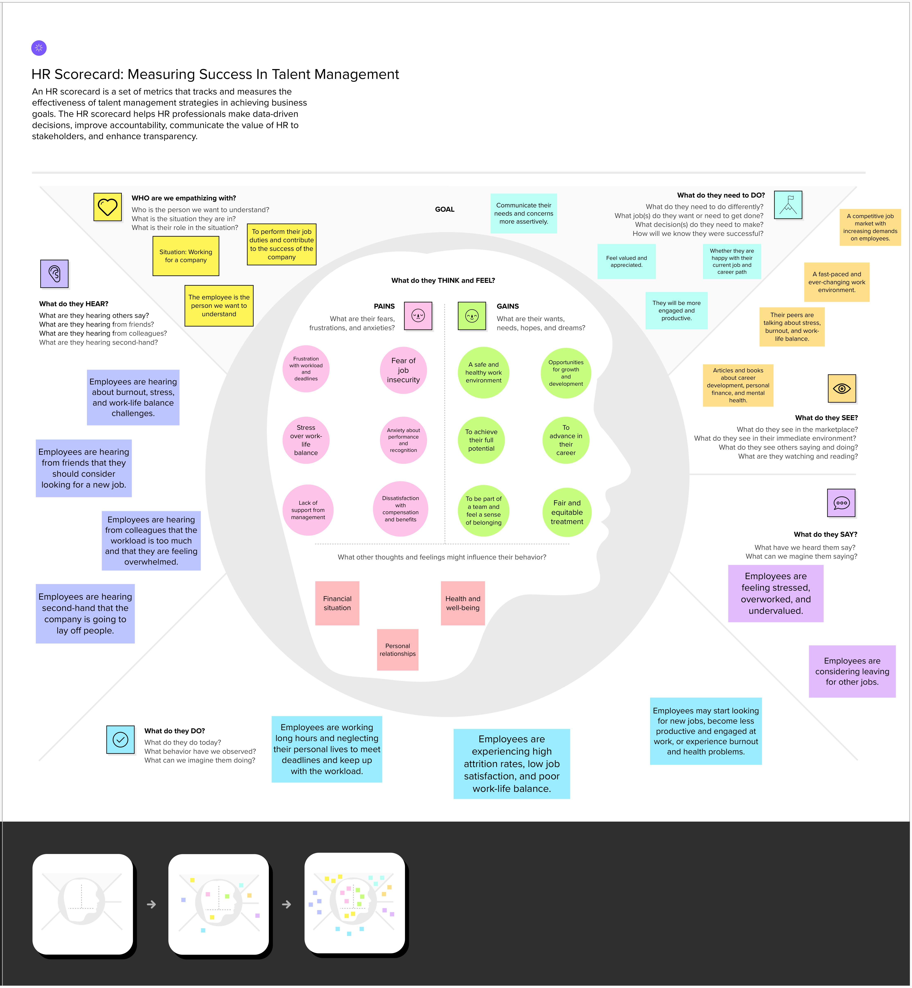

* 1. **Ideation & Brainstorming**

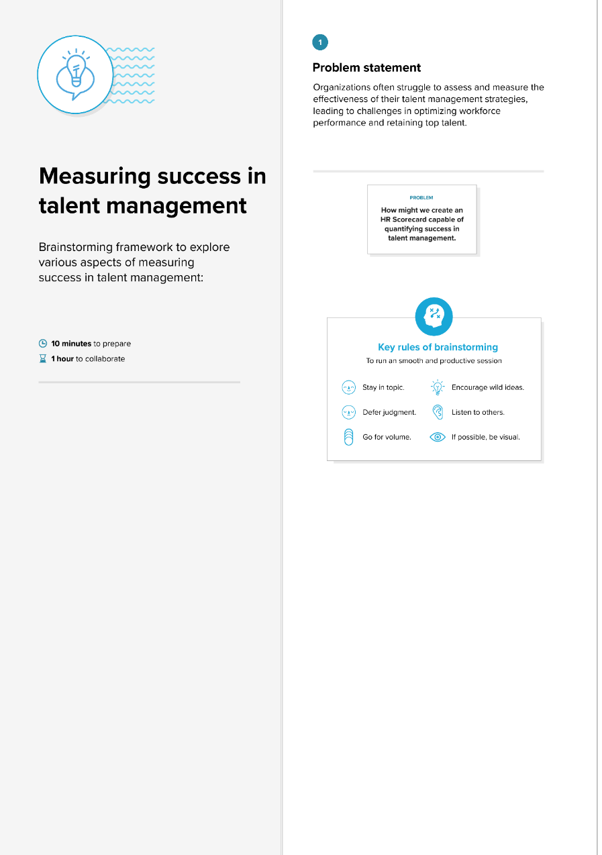

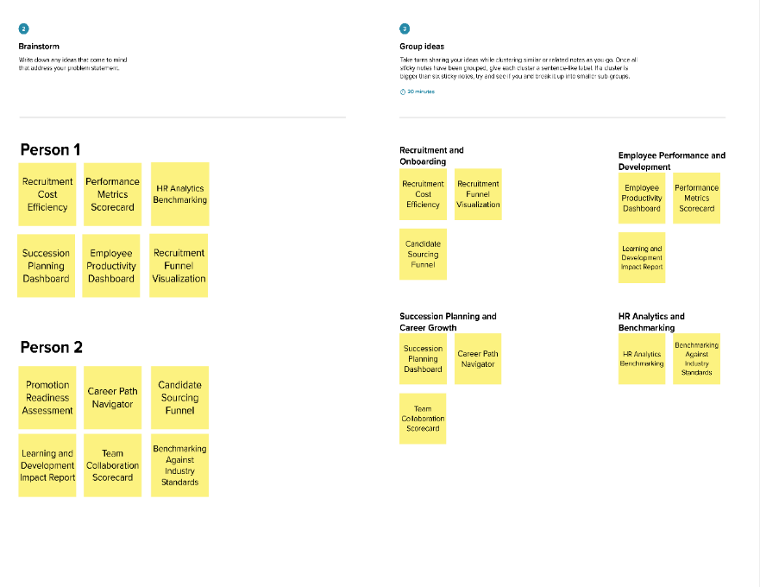

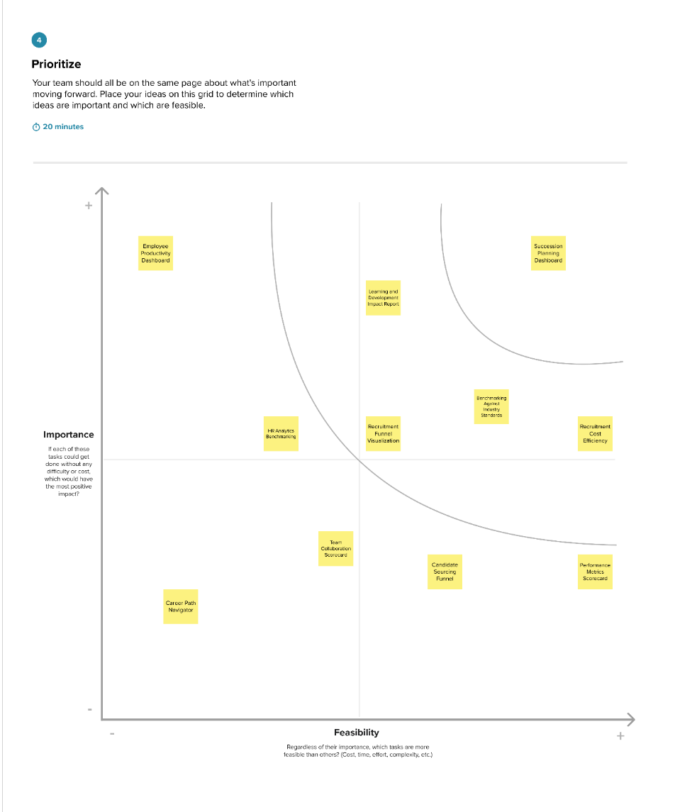

1. **REQUIREMENT ANALYSIS**
   1. **Functional requirement**

Data Integration

- The Tableau HR Scorecard should seamlessly integrate with existing HR databases and systems.

- Ensure real-time data updates for accurate and dynamic insights.

Key Metric Visualization

- Display essential HR metrics such as employee performance, retention rates, and talent development progress.

- Provide customizable dashboards for different stakeholders.

Talent Identification

- Implement algorithms to identify high-potential employees and areas for improvement.

- Enable tracking of individual and team performance over time.

Succession Planning

- Facilitate the creation of succession plans based on employee performance and potential.

- Ensure visibility into talent pipelines for critical roles.

Strategic Analytics

- Generate reports and analytics to support strategic decision-making in talent management.

- Enable scenario analysis for workforce planning and talent forecasting.

* 1. **Non-Functional requirements**

Scalability

- The system should handle a growing amount of data and users without compromising performance.

- Scale seamlessly as the organization expands.

Security

- Implement robust data encryption and user authentication mechanisms.

- Ensure compliance with data privacy regulations.

Usability

- Design an intuitive and user-friendly interface for users at various organizational levels.

- Provide training and documentation for easy adoption.

Performance

- Ensure quick response times for data queries and dashboard loading.

- Optimize system performance to handle concurrent user access.

Reliability

- Minimize downtime through regular maintenance and updates.

- Implement backup and recovery procedures to safeguard data.

Compatibility

- Ensure compatibility with different browsers and devices for widespread accessibility.

- Integrate with other HR and business applications seamlessly.

1. **PROJECT DESIGN**
   1. **Data Flow Diagram & User Stories**

**Data Flow Diagram:**

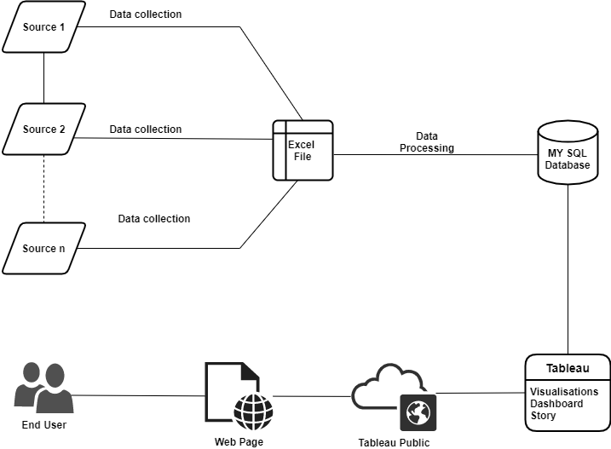

**User Stories**

| **User Type** | **Functional Requirement (Epic)** | **User Story Number** | **User Story / Task** | **Acceptance criteria** | **Priority** | **Release** |
| --- | --- | --- | --- | --- | --- | --- |
| HR Manager | Reporting | US1 | View interactive HR reports | Access reports with filters and drill down | High | Sprint 1 |
|  | Analysis | US2 | Analyse HR data | Slice, dice, filter, visualize HR data | High | Sprint 1 |
|  | Attrition | US3 | Analyse attrition drivers | Attrition dashboard with trends, analysis | Medium | Sprint 2 |
|  | Performance | US4 | View performance trends | Performance dashboard with KPIs, trends | Medium | Sprint 2 |
| Executive | Exec Reporting | US5 | View high level HR metrics | Executive dashboard with KPIs, drill down | High | Sprint 1 |
|  | Leader Compare | US6 | Compare metrics by leader | Reports to compare attrition, performance etc. | Medium | Sprint 2 |
|  | Trend Analysis | US7 | View HR metric trends | Timeseries analysis of HR KPIs | Medium | Sprint 3 |
| Employee | Self-Service | US8 | View and update profile | Update profile data like compensation, contact info | Low | Sprint 3 |

* 1. **Solution Architecture**

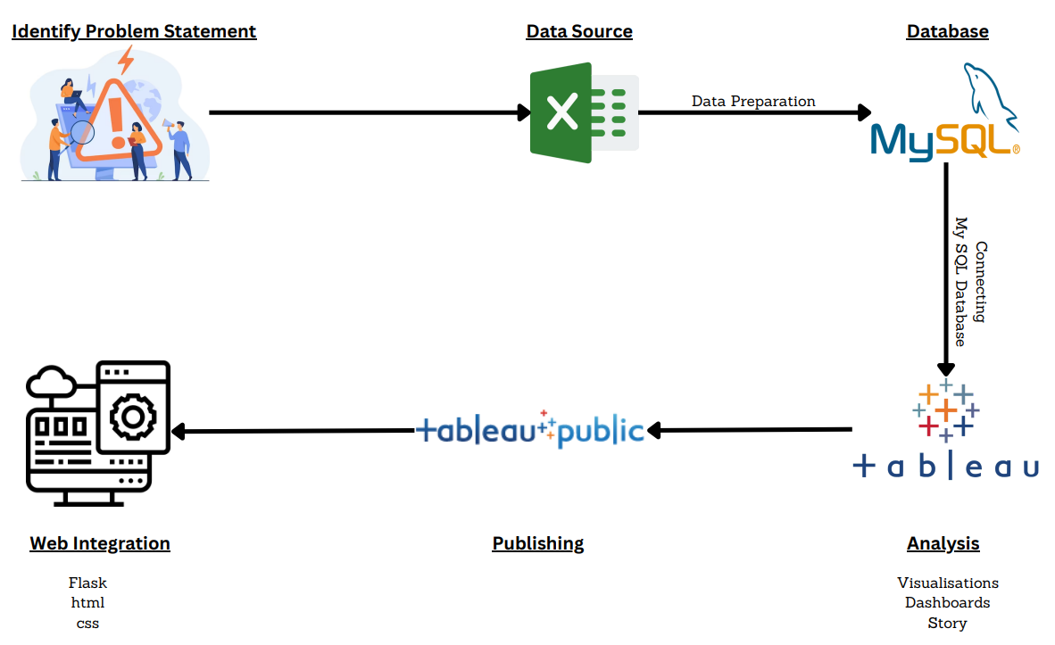

1. **PROJECT PLANNING & SCHEDULING**
   1. **Technical Architecture**

**Table-1 : Components & Technologies:**

|  |  |  |  |
| --- | --- | --- | --- |
| **S.No** | **Component** | **Description** | **Technology** |
| 1. | Data Sources | Data sources will provide the raw data needed for your analysis. These sources may include HR databases, employee surveys, and external benchmarking data. | SQL for database querying, data extraction tools (e.g., ETL tools) for data preparation. |
| 2. | Data Preparation and Cleaning | This component involves cleaning, transforming, and structuring the raw data to make it suitable for analysis. | Tools like Python (with libraries such as Pandas) or R for data cleaning and transformation. |
| 3. | Data Storage | Store the cleaned and transformed data for efficient retrieval during analysis. | Relational database management system (SQL) or a data warehouse if dealing with large datasets. |
| 4. | Data Analysis | This is where you perform the actual data analysis to derive insights and metrics related to talent management. | Tableau for data visualization and analysis, and statistical analysis tools for advanced analytics. |
| 5. | Tableau Dashboard Development | Create interactive and informative dashboards to present your HR Scorecard. | Tableau for dashboard design and visualization. |
| 6. | Reporting and Presentation | Prepare reports and presentations to communicate your findings to stakeholders. | Microsoft Office Suite (e.g., PowerPoint, Word) for creating reports and presentations. |
| 7. | Security and Access Control | Ensure that only authorized users have access to sensitive HR data. | Role-based access control, encryption, and authentication mechanisms. |
| 8. | Documentation and Version Control | Maintain documentation of your project, code, and data sources for future reference. | Version control systems like Git for code and documentation management. |
| 9. | Backup and Recovery | Implement backup and recovery procedures to protect against data loss. | Automated backup solutions, regular database snapshots. |
| 10. | Ethical Considerations | Ensure that your project complies with privacy and data protection regulations. | Compliance management tools and practices. |
| 11. | Testing and Validation | Before finalizing your analysis and reports, thoroughly test and validate your findings. | Statistical validation methods, peer review, testing frameworks. |

**Table-2: Application Characteristics:**

|  |  |  |  |
| --- | --- | --- | --- |
| **S.No** | **Characteristics** | **Description** | **Technology** |
| 1. | User-Friendly Interface | Create an intuitive and user-friendly interface using Tableau to ensure that users can easily interact with the HR Scorecard. | Tableau for creating interactive and user-friendly dashboards. |
| 2. | Data Security | Implement strong data security measures to protect sensitive HR data from unauthorized access. | Role-based access control, encryption, and secure authentication mechanisms. |
| 3. | Scalability | Design the application to handle an increasing volume of HR data and growing user demands. | Cloud hosting platforms (e.g., AWS, Azure), load balancing, and scaling for Tableau Server/Online. |
| 4. | Collaboration and Sharing | Enable users to collaborate and share HR data and insights with colleagues and stakeholders. | Utilize Tableau's collaboration and sharing features, and integrate with communication tools (e.g., Slack, Microsoft Teams). |

1. **CODING & SOLUTIONING (Explain the features added in the project along with code)**
   1. **Feature 1**

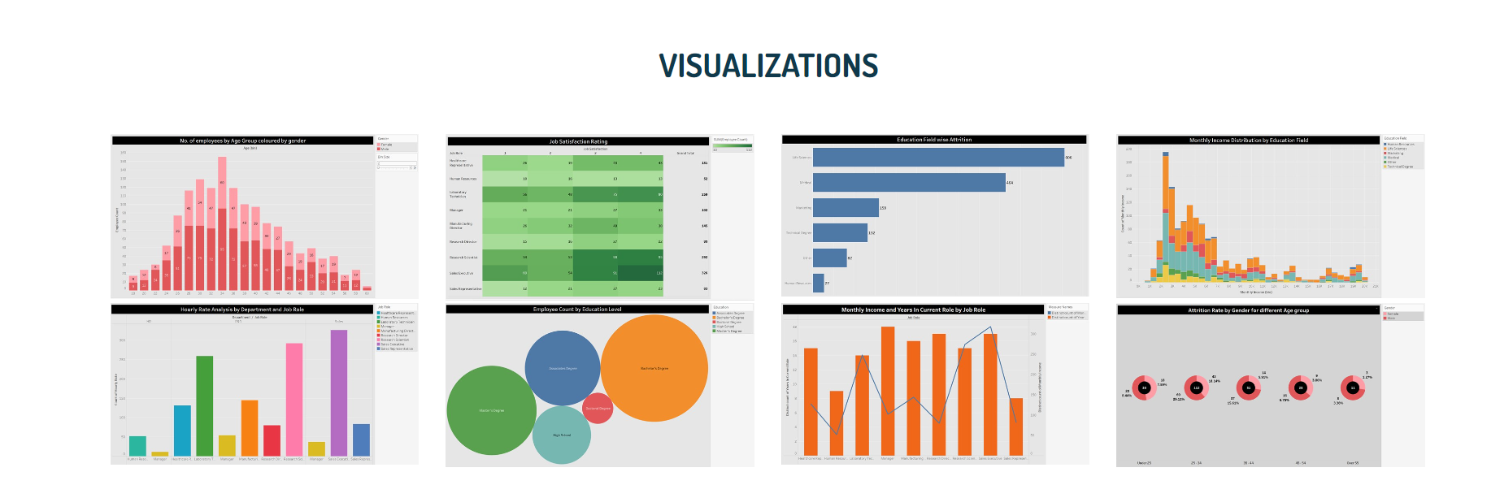

* More visualisations has been added.

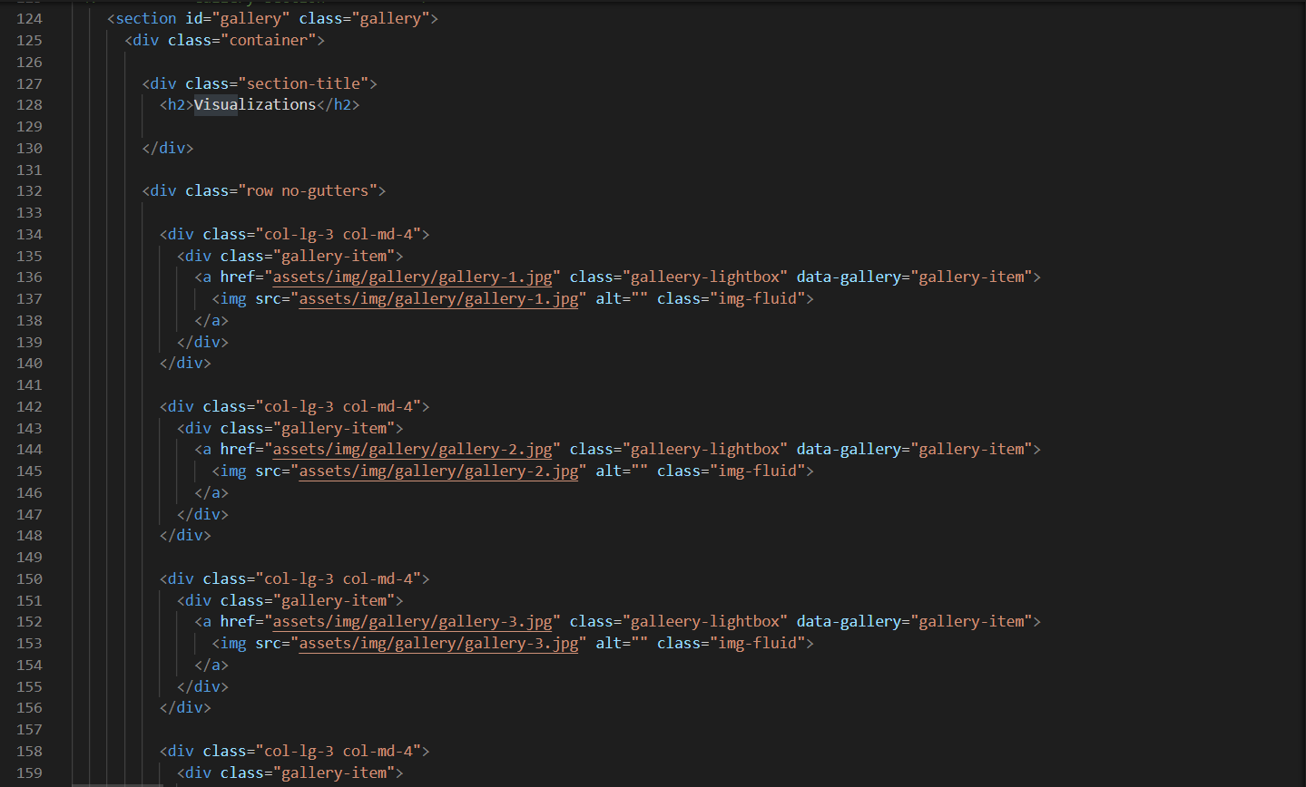

* 1. **Feature 2**



* Shortcuts have been provided

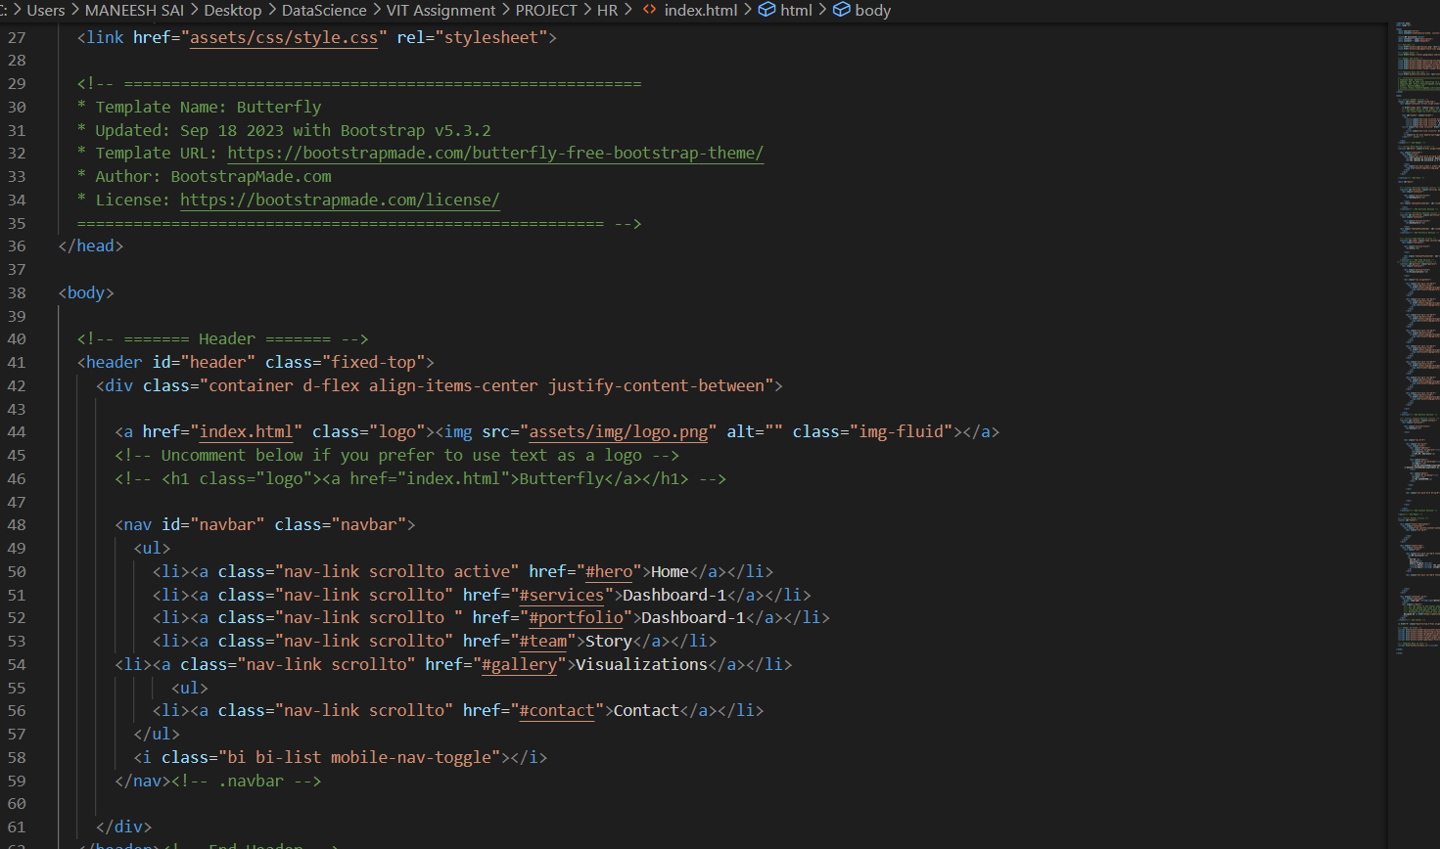

1. **PERFORMANCE TESTING**
   1. Performance Metrics

|  |  |  |
| --- | --- | --- |
| **S.No.** | **Parameter** | **Screenshot / Values** |
|  | Dashboard Design | No of Visualizations / Graphs – 16 |
|  | Data Responsiveness | Dashboards – 2 |
| 3. | Amount Data to Rendered (DB2 Metrics) | No. of Columns – 1471 |
| 4. | Utilization of Data Filters |  |
| 5. | Effective User Story | No of Scene Added –  8 |

1. **RESULTS**
   1. Output Screenshots

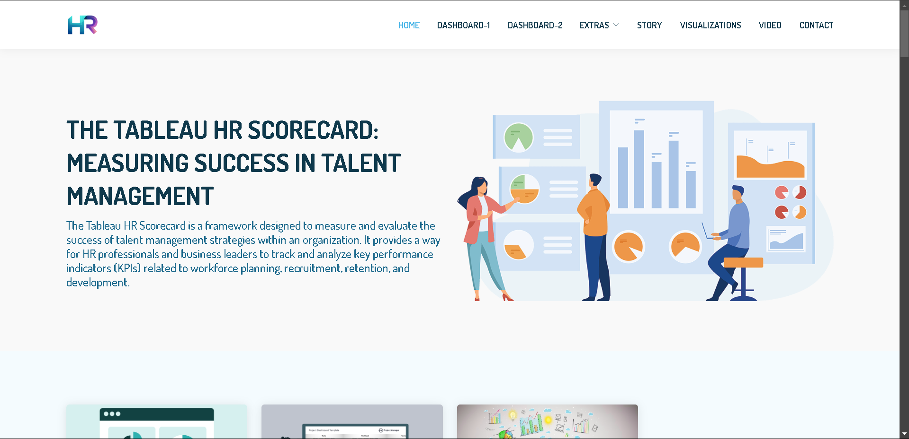

1. **ADVANTAGES & DISADVANTAGES**

**Advantages:**

**1. Dynamic Customization:**

- Enhances user engagement by allowing dynamic customization of dashboards based on specific metrics and views.

**2. Automated Succession Planning:**

- Streamlines talent identification and development, optimizing workforce planning and ensuring continuity in critical roles.

**3. Data-Driven Decision-Making:**

- Enables organizations to make informed decisions by providing real-time insights and strategic analytics.

**4. User-Friendly Interface:**

- Improves usability with an intuitive interface, making it accessible to users at various organizational levels.

**5. Scalability and Compatibility:**

- Supports organizational growth with scalability and ensures widespread accessibility through compatibility with different devices and browsers.

**Disadvantages:**

**1. Technical Complexity:**

- Implementing and maintaining the system may require technical expertise, potentially posing a challenge for non-technical users.

**2. Data Security Concerns:**

- Handling sensitive HR data raises concerns about data security and privacy. Robust security measures are crucial to address these concerns.

**3. Initial Implementation Costs:**

- Setting up the Tableau HR Scorecard may involve initial implementation costs, including software licensing, training, and customization expenses.

**4. Dependency on Data Quality:**

- The effectiveness of the system is highly dependent on the quality and accuracy of the input data. Inaccurate or incomplete data can lead to flawed insights.

**5. Resistance to Change:**

- Introducing a data-driven approach may face resistance from employees accustomed to traditional methods. Change management strategies are essential for successful adoption.

1. **CONCLUSION**

The Tableau HR Scorecard is a valuable tool for organizations that want to measure and improve the effectiveness of their talent management initiatives. By tracking and analyzing key HR KPIs, organizations can identify areas for improvement and make data-driven decisions that will lead to a more engaged and productive workforce.

The Tableau HR Scorecard is also a powerful tool for demonstrating the value of HR to the organization. By showing stakeholders how HR initiatives are impacting key business metrics, such as employee engagement, turnover, and productivity, the Tableau HR Scorecard can help to build a stronger case for HR investment.

Overall, the Tableau HR Scorecard is a valuable tool for organizations that are serious about improving their talent management performance and demonstrating the value of HR to the business.

1. **FUTURE SCOPE**

The future scope of the Tableau HR Scorecard is very promising. As HR organizations continue to embrace data-driven decision-making, the Tableau HR Scorecard will become an increasingly valuable tool.

Here are some specific areas where the Tableau HR Scorecard could be further developed:

* Integration with other HR systems: The Tableau HR Scorecard could be integrated with other HR systems, such as HRIS, talent management systems, and learning management systems. This would allow organizations to track and analyze HR data from a single source.
* Real-time data visualization: The Tableau HR Scorecard could be used to create real-time dashboards that provide organizations with insights into their HR performance. This would allow organizations to identify and address problems quickly.
* Predictive analytics: The Tableau HR Scorecard could be used to apply predictive analytics to HR data. This would allow organizations to predict future HR trends and make more informed decisions.
* Machine learning: The Tableau HR Scorecard could be used to implement machine learning algorithms to automate the analysis of HR data. This would free up HR professionals to focus on more strategic tasks.

Overall, the Tableau HR Scorecard has the potential to revolutionize the way that HR organizations measure and manage their talent. By embracing the future trends of data integration, real-time data visualization, predictive analytics, and machine learning, the Tableau HR Scorecard can become an even more powerful tool for organizations that are serious about improving their talent management performance.

1. **APPENDIX**

**Source Code**

<https://drive.google.com/drive/folders/1ZI8LUfFhDywPEWzUVYv6IABecdxhipWb?usp=sharing>

**GitHub & Project Demo Link**

**GitHub Link**

[paidimaneesh/SDP - GitHub](https://github.com/paidimaneesh/SDP)

**Project Demo Link**

<https://drive.google.com/file/d/119JJDIjTLQEWZ5l1crN3fwQuFGi7ssqO/view?usp=sharing>